<https://github.com/sdiepend/Udacity-DAND/blob/master/P1%20-%20Test%20a%20Perceptual%20Phenomenon/Lesson%206/PS%206%20-%20Normal%20Distribution.ipynb>

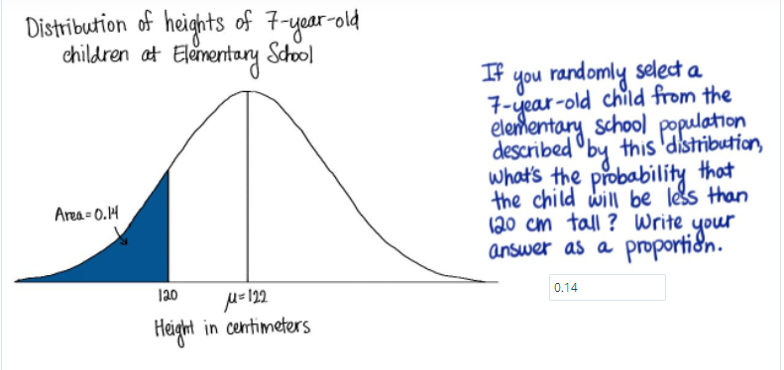

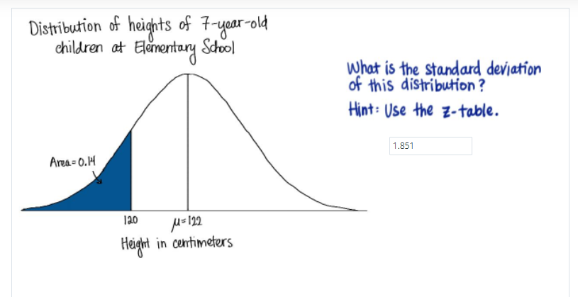

Source:<http://www.z-table.com/>

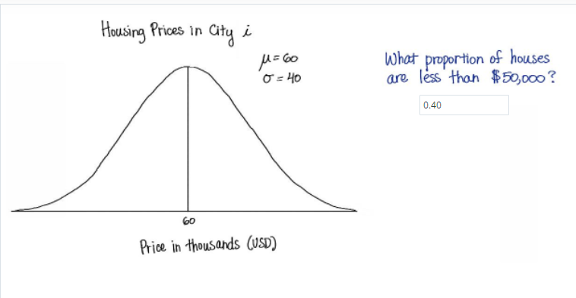

(50**-**60)**/**40

Z = -0.25

**Answer:** 0.4013

Source <https://s3.amazonaws.com/udacity-hosted-downloads/ZTable.jpg>

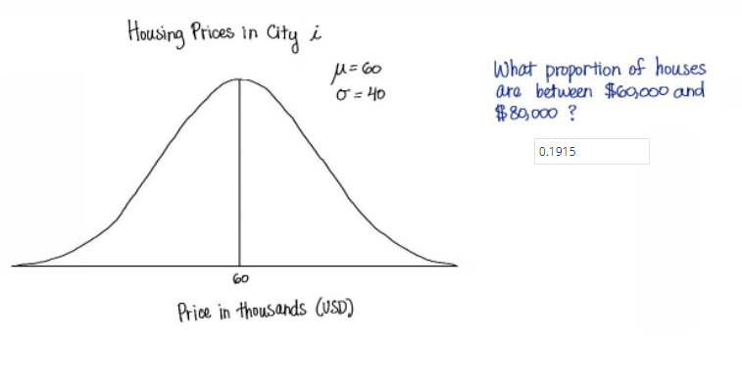

What proportion of houses are between $60000 and $80000?

**Answer:** $60000 is the mean, so proportion is 0.50, $80000 has a z-score equal to 0.5, for which the proportion is 0.6915. 0.6915 minus 0.5000 is 0.1915.

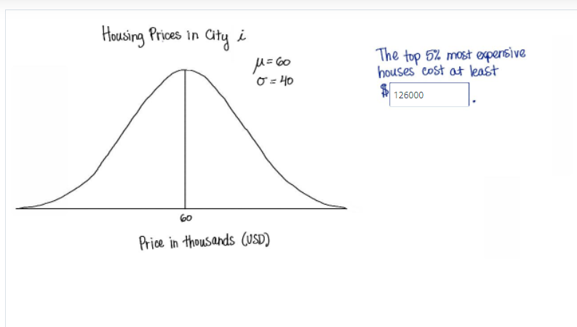

The top 5% most expensive houses cost at least $_____.

1.65**\***40 **+** 60

:

126.0

126.0 * 1000 = 126000

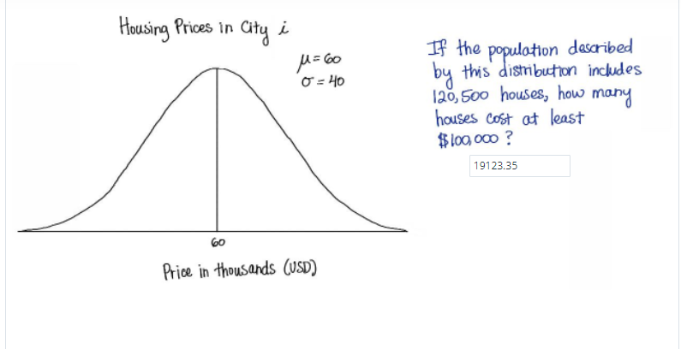

z=(100-60)/40 = 1, then the proportion of z is 0.8413.

Then, 120500**\***(1**-**0.8413) 19123.35

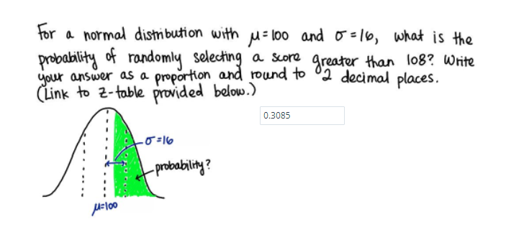

*# Z-score = 0.5*

1**-**0.6915

0.3085

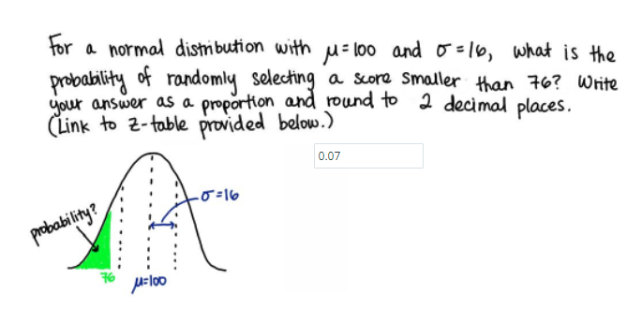

*#Z-score -1.5*

0.0668

0.0668

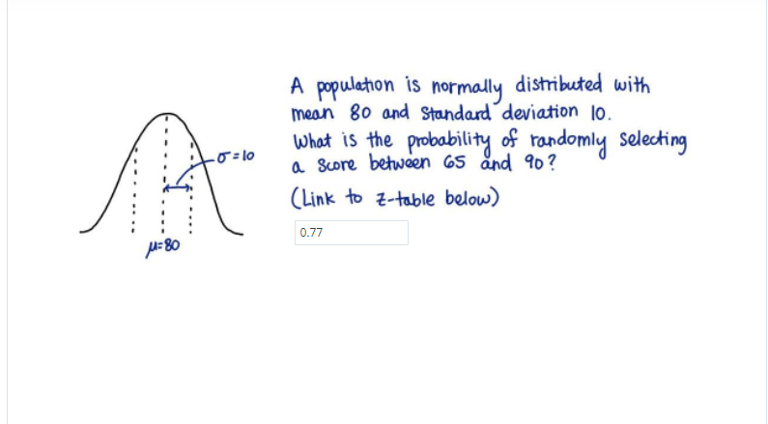

z_score65 **=** **-**1.5

z_score90 **=** 1

prop1 **=** 0.0668

prop2 **=** 0.8413

prop2 **-** prop1

0.7745000000000001 0.77

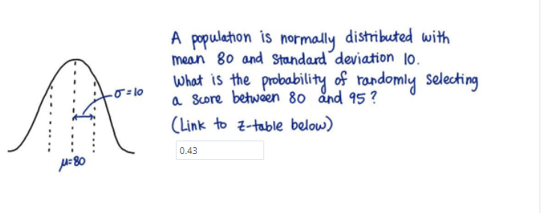

z_score80 **=** 0

z_score90 **=** 1.5

prop1 **=** 0.5000

prop2 **=** 0.9332

prop2 **-** prop1

Out[10]:

0.43320000000000003 0.43

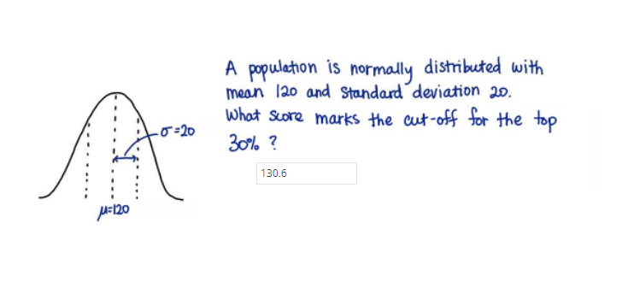

z=0.3

1-0.3= 0.7 => 0.53

0.53**\***20 **+** 120

=130.6

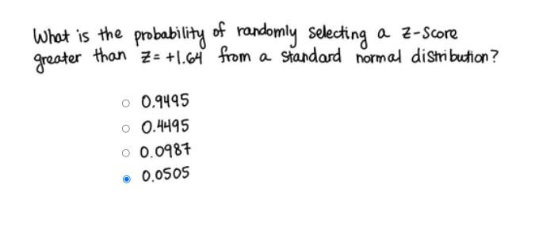

1 **-** 0.9495

0.05049999999999999 0.0505

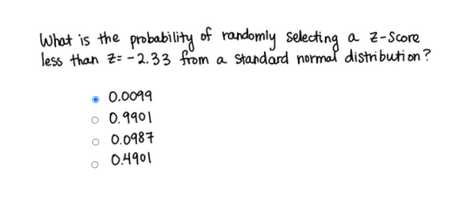

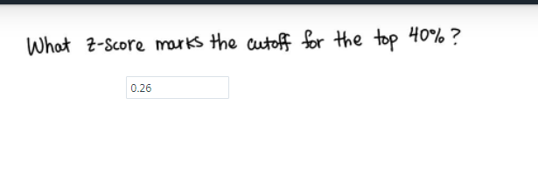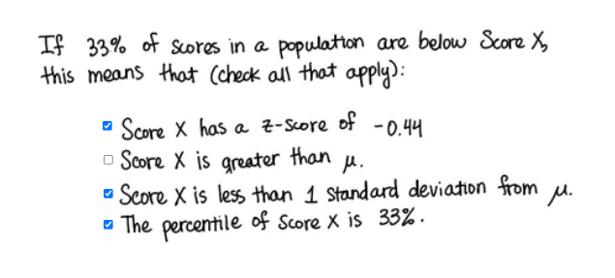

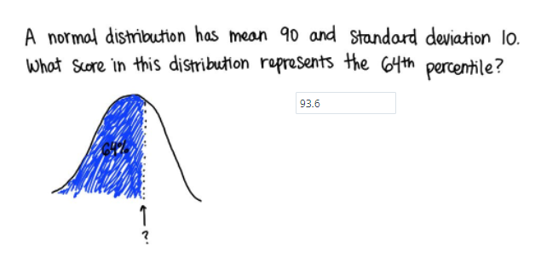

Z = 1-0.64 = 0.36

0.36**\***10**+**90

93.6